Deployment Test Report: Four-Bay Truss
Test campaign DT-07 · Prepared for internal review

1. Summary
The four-bay truss deployed fully in all six ground tests. Deployment took 11.8 s on average, within the 15 s requirement. Peak latch load stayed under 40% of the allowable. One test showed a brief hinge bind at bay 3, cleared by the spring margin without intervention.

2. Deployment sequence
Figure 1 shows the panel stack unfolding from its stowed state. The motion is the same sequence the flight unit will perform after separation.

Figure 1. Panel deployment sequence (animated).
For comparison, the stowed configuration before release:
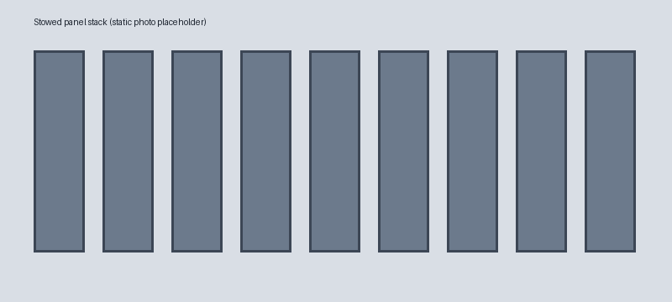
Figure 2. Stowed configuration (still image).

3. Results
Test | Deploy time (s) | Peak latch load (N) | Result
DT-07-1 | 11.2 | 182 | Pass
DT-07-2 | 12.1 | 190 | Pass
DT-07-3 | 13.4 | 204 | Pass, hinge bind
DT-07-4 | 11.0 | 176 | Pass
DT-07-5 | 11.6 | 185 | Pass
DT-07-6 | 11.5 | 181 | Pass

4. As-built geometry
Figure 3 turns the as-built truss through a full revolution so reviewers can check bay alignment from every side without opening CAD.
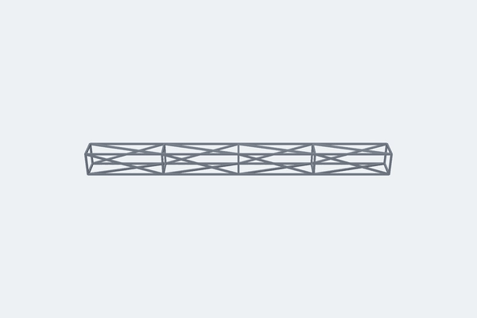
Figure 3. As-built truss, full revolution (animated).

5. Open items
- Root-cause the bay 3 hinge bind (suspected burr on pin, inspect before DT-08).
- Repeat DT-07-3 with the replacement pin.
- Add thermal soak at -40 °C before the next deployment series.

6. Conclusion
The design meets its deployment requirements on the ground. The team recommends proceeding to thermal vacuum testing once the hinge bind is closed out.

